T5.1 Unity Assets
Agra Casal Rubén

Assets de texturas pixel art (gratis )
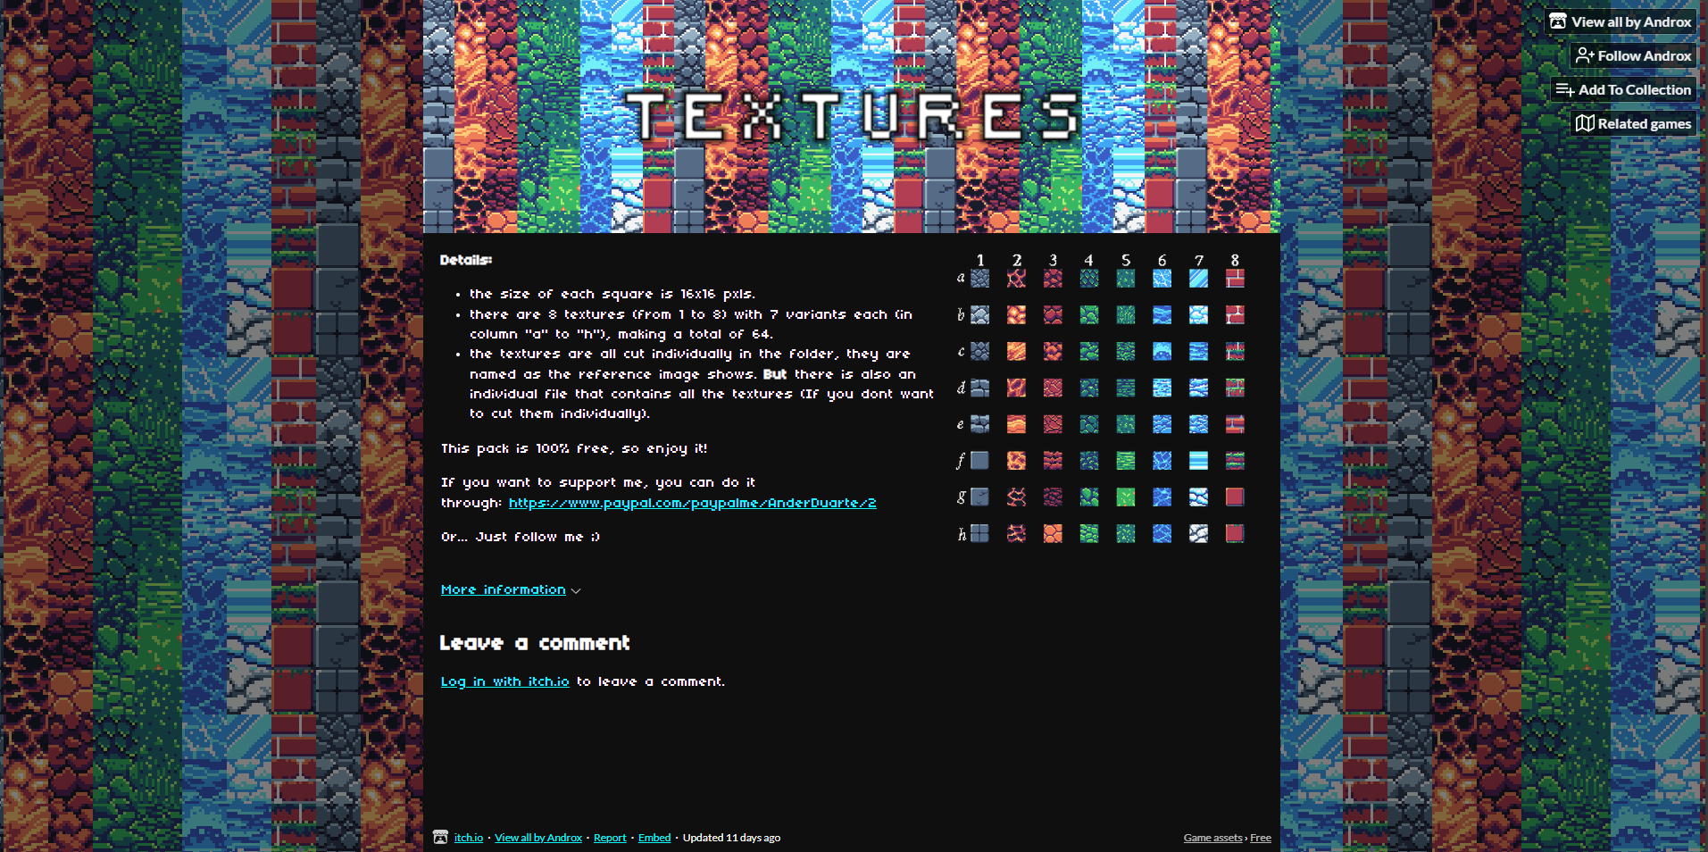

Fuente: https://byandrox.itch.io/32-16pxs-textures

Assets de audio (gratis)
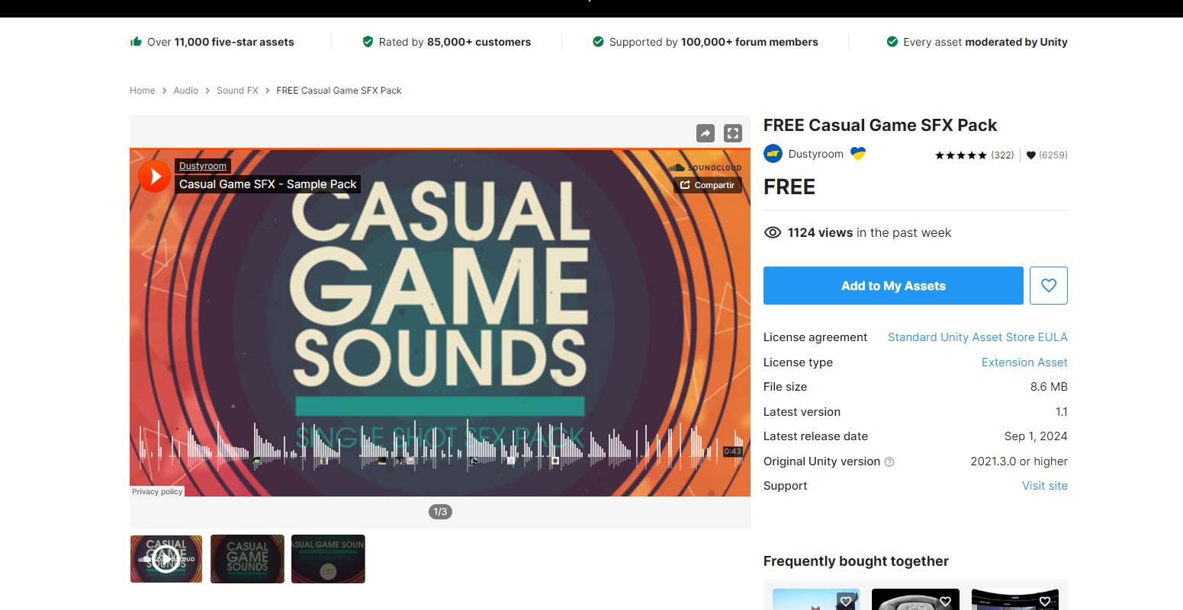

Fuente: https://assetstore.unity.com/packages/audio/sound-fx/free-casual-game-sfx-pack-54116

Assets modelo 3D (50$)
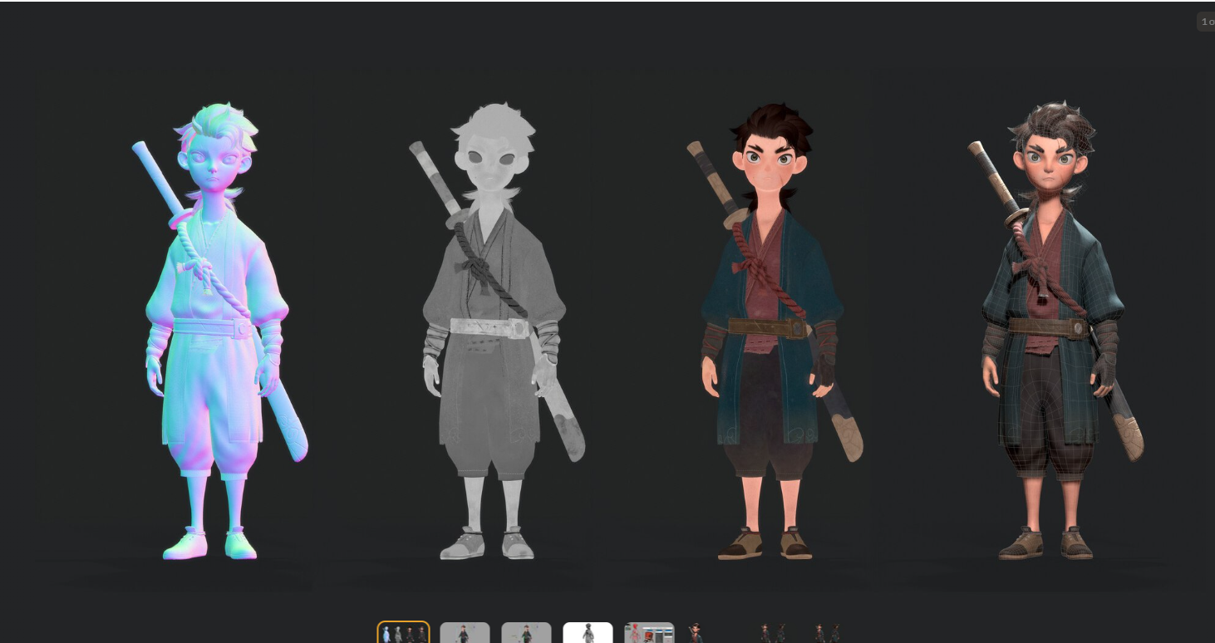

Fuente: https://www.turbosquid.com/3d-models/shao-nian-anim-rig-2133488

Asset de sprites (gratis)
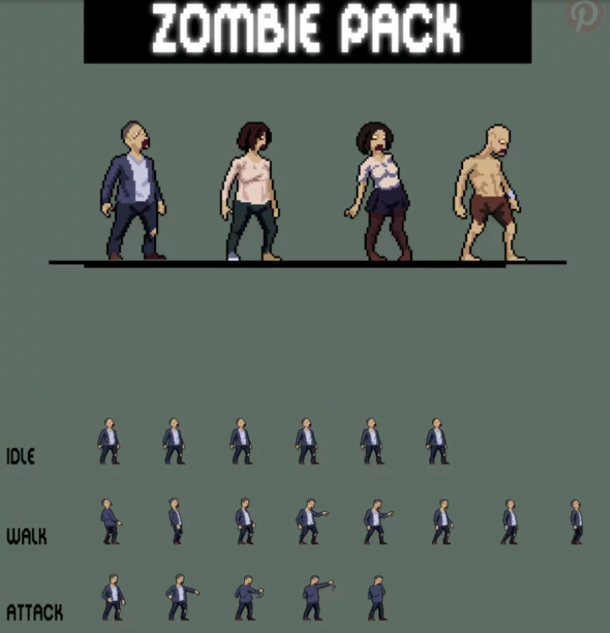

Fuente: https://craftpix.net/freebies/free-urban-zombie-sprite-sheet-pixel-art-pack/

